Date
Phone
Email
Website

Recipient
Recipient’s Address

Dear Recipient,

My name is Name. I am the current President of IEEE (Institute of Electrical and Electronics Engineers) at the University of New Mexico. IEEE at UNM supports students of all different backgrounds such as computer science, electrical, computer, and mechanical engineering. Our student chapter is one of many branches that participate in IEEE globally. We host events throughout the semester such as resume workshops, networking opportunities, and presentations from local recruiters for companies.

Our biggest event of the year is the IEEE Rising Stars Conference which occurs in Las Vegas, Nevada. This conference is the first IEEE conference of the year and is specific to students and young professionals. Unique only to our chapter is that we volunteer with IEEE to run a booth at the CES (Consumer Electronics Show). This show occurs right after the Rising Stars Conference and allows our students the opportunity to see the cutting-edge technology that is being developed around the world. This is a unique opportunity for college students as all attendees must be media or related to an industry. As a student chapter, we try to attend this event every year. The experiences that students obtain at these events stay with them through their time in college and into their professional careers.

Due to rising costs of registration, hotel, and travel costs we have had to limit the number of students that can attend. For this reason, we are reaching out to local companies for help in sponsoring our chapter to attend such events. In return for sponsorship, IEEE can offer marketing and exposure through our website, newsletters, and yearly t-shirts. Additionally, we can offer a pipeline to talented students at The University of New Mexico who are seeking internships and employment opportunities. Our sponsorship packages range from $500 - $1500 and include tiers of benefits. I plan to follow up with you in the next few weeks via phone call. I am looking forward to speaking with you and answering any questions you may have.

Sincerely,
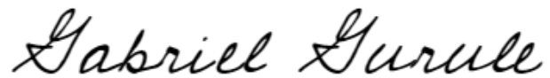

Gabriel Gurulé
IEEE@UNM President

Sponsorship Tiers

Higher Tiers Include Benefits of Previous Tiers

Kilowatt: $500
• Logo on IEEE@UNM T-Shirt
• Logo on Website and Recruiting Page

Megawatt: $1000
• Logo On Meeting Documents
• Social Media Promotion / Recruiting

Gigawatt: $1500

• Sponsor Logo on Banner
• Student Resume’s

